**Use instructions of Arduino IDE is shown in the following picture:**

!!!Note:If you need to upload the code, you need to remove the Bluetooth module or turn the Download switch to ON, which next to the Bluetooth module.

1.You need to double-click to open the Arduino software that is installed on the desktop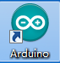.

2.You need to connect the Arduino UNO board to the computer with the data cable.

And select “Port” in the device manager of your computer, marked with **CH340 port.** For example:USB-SERIAL CH340(COM6), as shown in the following picture.

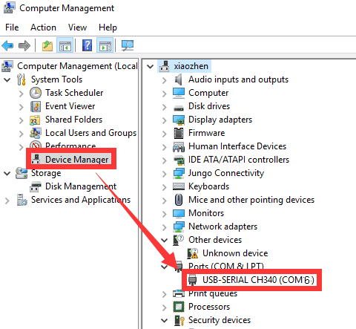

3.You need to select 【Tool】--【Board】--【Arduino Uno】 in the Arduino IDE menu bar, as shown in the following picture.

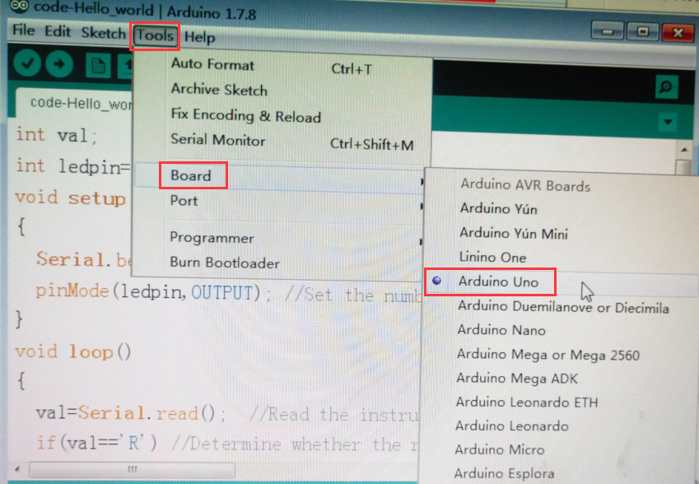

4.In the menu bar of Arduino IDE, you can select the 【Tools】---【Port】--- select the port that the serial number displayed by the device manager just now. for example:COM6.

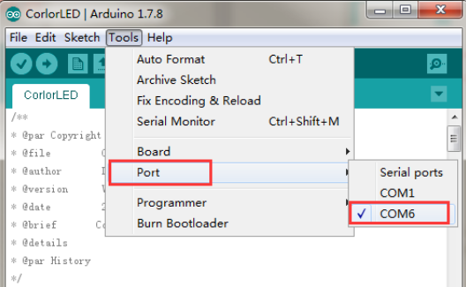

1. You can write codes in the blank area or directly open the file in .ino format, as shown in the following picture.

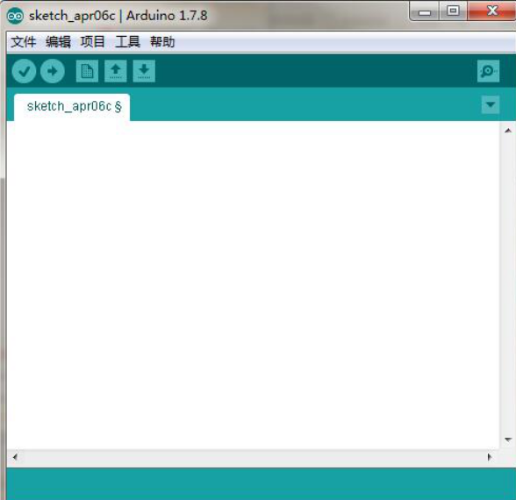



6.After the codes is written, you need to click“**√**” in the menu bar to compile the program, and wait for the word "**Done compiling** " in the lower right corner, as shown in the figure below.

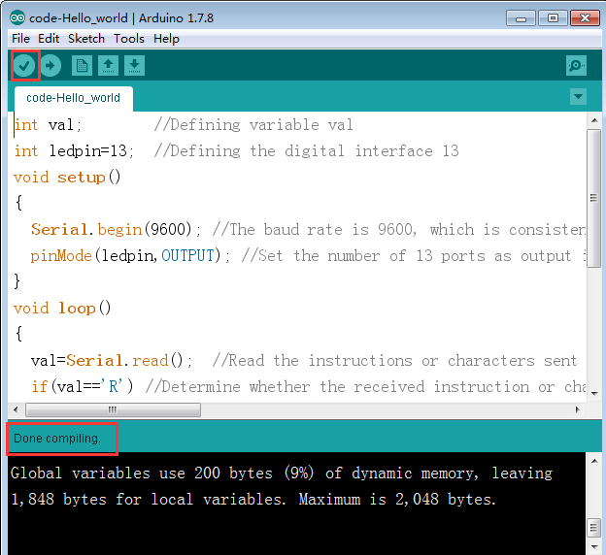

7.You can click “**→**”under the menu bar to upload the program to the Arduino UNO board. When the word “**Done uploading**” appears in the lower left corner, the program has been successfully uploaded to the Arduino UNO board, as shown in the figure below.

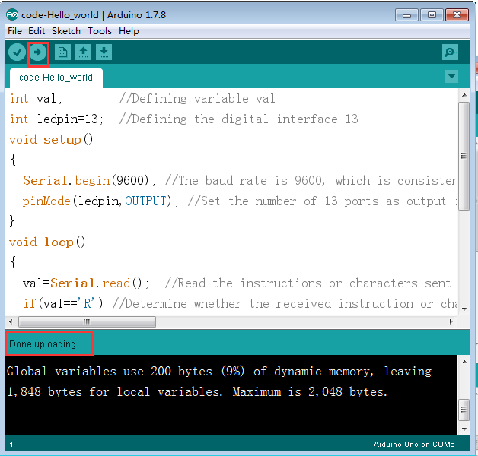

After these steps, the program is uploaded to the Arduino UNO board successfully.